**HOW TO:**

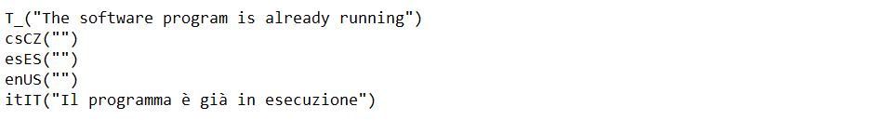

New language:

csCZ = Polish  
esES = Spanish

enUS = English

itIT = Italian

Translation in use

Here below in bolt a few examples of formatting tags not to be translated:

* T_("**@@iml:1950*1200`**carpenteria:dentedoppio`")
* T_("**[A2>** Pag. **$$P**")
* T_("τ**[,** d**]** < f**[,** v,d]")